Student

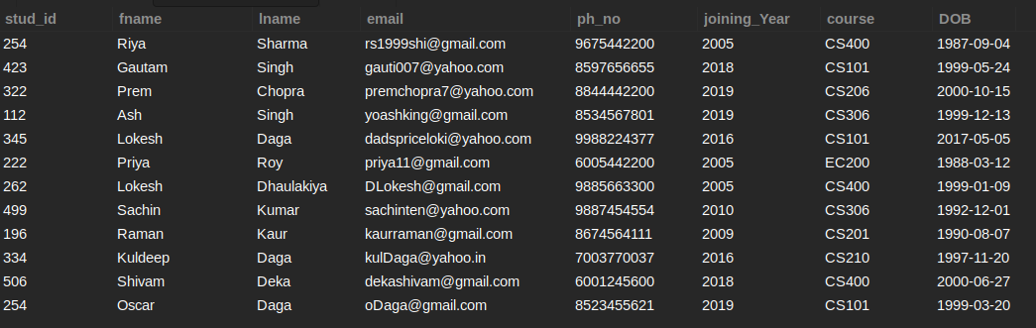

E_TRANSACTIONS

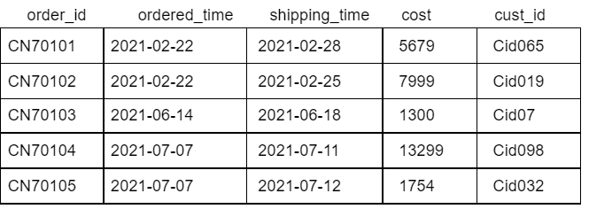

Q19: List down all the details of students sorted in ascending order w.r.t their surname.

SELECT * FROM STUDENT ORDER BY LNAME;

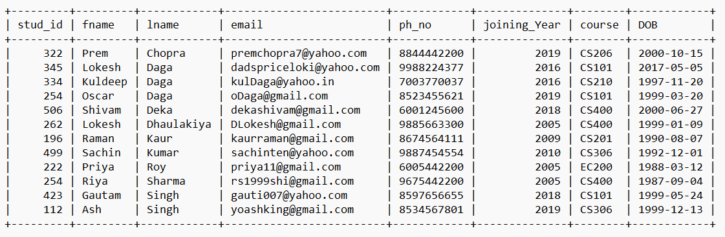

Q20: List out all the details of the students where they are listed in ascending order w.r.t the fname and then listed in descending order w.r.t the lname.

SELECT * FROM STUDENT ORDER BY FNAME, LNAME DESC;

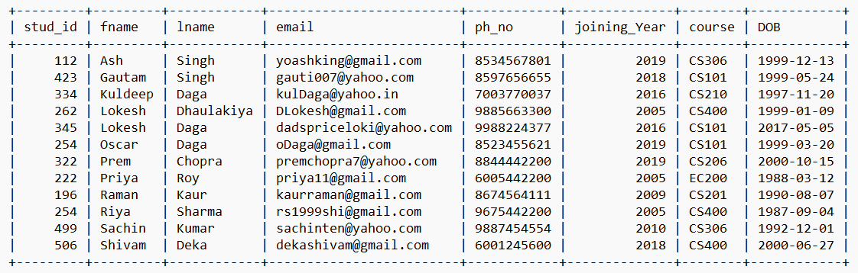

Q21: Fetch out the email ids of all students who joined in 2005 and sort them in descending order wrt date of birth of the students.

SELECT EMAIL FROM STUDENT WHERE JOINING_YEAR = 2005 ORDER BY DOB DESC;

+---------------------+

| EMAIL |

+---------------------+

| DLokesh@gmail.com |

| priya11@gmail.com |

| rs1999shi@gmail.com |

+---------------------+

Q22: List out the complete name of all the students who enrolled in CS206 batch 2019 and sort them in ascending order according to their date of birth and lname.

SELECT FNAME, LNAME FROM STUDENT WHERE COURSE = 'CS206' AND JOINING_YEAR = 2019 ORDER BY DOB, LNAME;

+-------+--------+

| FNAME | LNAME |

+-------+--------+

| Prem | Chopra |

+-------+--------+

Q23: List down the Order ID’s and their respective Ordering time, arranged in Ascending order by ordering time.

SELECT ORDER_ID, ORDERED_TIME FROM E_TRANSACTIONS ORDER BY ORDERED_TIME;

+----------+--------------+

| ORDER_ID | ORDERED_TIME |

+----------+--------------+

| CN70101 | 2021-02-22 |

| CN70102 | 2021-02-22 |

| CN70103 | 2021-06-14 |

| CN70104 | 2021-07-07 |

| CN70105 | 2021-07-07 |

+----------+--------------+

Q24: Arrange the above-given data in descending order by Shipping time.

SELECT * FROM E_TRANSACTIONS ORDER BY SHIPPING_TIME DESC;

order_id | ordered_time | shipping_time | cost | cust_id

----------+--------------+---------------+-------+---------

CN70105 | 2021-07-07 | 2021-07-12 | 1754 | Cid032

CN70104 | 2021-07-07 | 2021-07-11 | 13299 | Cid098

CN70103 | 2021-06-14 | 2021-06-18 | 1300 | Cid07

CN70101 | 2021-02-22 | 2021-02-28 | 5679 | Cid065

CN70102 | 2021-02-22 | 2021-02-25 | 7999 | Cid019

Q25: Fetch out all the records but in descending order by ordering time and in case of similar order times sort in ascending order w.r.t. shipping time.

SELECT * FROM E_TRANSACTIONS ORDER BY ORDERED_TIME DESC, SHIPPING_TIME;

order_id | ordered_time | shipping_time | cost | cust_id

----------+--------------+---------------+-------+---------

CN70104 | 2021-07-07 | 2021-07-11 | 13299 | Cid098

CN70105 | 2021-07-07 | 2021-07-12 | 1754 | Cid032

CN70103 | 2021-06-14 | 2021-06-18 | 1300 | Cid07

CN70102 | 2021-02-22 | 2021-02-25 | 7999 | Cid019

CN70101 | 2021-02-22 | 2021-02-28 | 5679 | Cid065

Q26: List down all the order details whose cost is less than 5000 , in ascending order by cost.

SELECT * FROM E_TRANSACTIONS WHERE COST < 5000 ORDER BY COST;

order_id | ordered_time | shipping_time | cost | cust_id

----------+--------------+---------------+------+---------

CN70103 | 2021-06-14 | 2021-06-18 | 1300 | Cid07

CN70105 | 2021-07-07 | 2021-07-12 | 1754 | Cid032

Q27: List down the orders ids with their shipping time which were ordered before 30th June 2021 sort them in ascending order w.r.t. cost and in descending order w.r.t. time the purchase was made.

SELECT ORDER_ID, SHIPPING_TIME FROM E_TRANSACTIONS WHERE SHIPPING_TIME < '2021-06-30' ORDER BY COST, ORDERED_TIME DESC;

order_id | shipping_time

----------+---------------

CN70103 | 2021-06-18

CN70101 | 2021-02-28

CN70102 | 2021-02-25

Q28: List down all the details of the orders made in February 2021 or July 2021, also sort them in ascending order by their price.

SELECT * FROM E_TRANSACTIONS WHERE ORDERED_TIME LIKE '2021-02-%' OR ORDERED_TIME LIKE '2021-07-%' ORDER BY COST;

+----------+--------------+---------------+-------+---------+

| order_id | ordered_time | shipping_time | cost | cust_id |

+----------+--------------+---------------+-------+---------+

| CN70105 | 2021-07-07 | 2021-07-12 | 1754 | Cid032 |

| CN70101 | 2021-02-22 | 2021-02-28 | 5679 | Cid065 |

| CN70102 | 2021-02-22 | 2021-02-25 | 7999 | Cid019 |

| CN70104 | 2021-07-07 | 2021-07-11 | 13299 | Cid098 |

+----------+--------------+---------------+-------+---------+